BC Children's Hospital Research Institute | The University of British Columbia
950 West 28th Avenue | Vancouver BC | V5Z 4H4 Canada
Phone +1 604 875 2422 | Fax: +1 604 875 2635
vecstudies@bcchr.ubc.ca | Twitter: @vec_ubc | Facebook: vec.ubc
https://www.bcchr.ca/vec

SPRING STUDY
Full Title: Severe acute respiratory-syndrome related coronavirus 2 prevalence in children and young adults in British Columbia: an observational study

DRIED BLOOD SPOT (DBS) SAMPLE COLLECTION VIA HEEL PRICK
INSTRUCTION MANUAL

Please read the instructions carefully. You can visit our study webpage at https://bcchr.ca/vec/research/spring-study for instructional videos and more guidance.
If you have any questions or concerns, please contact us:
604-875-2187
springstudy.vec@bcchr.ca

Check that you have the following items from the kit to do the dry blood spot (DBS) test on your baby or child:
- 1 “903 protein saver card” with 5 blank circles to collect blood onto: look for a coloured label that says “lift cover & fill circles with blood.” Do not confuse this with the humidity indicator card with blue circles!
- 2 lancets: If you are unsuccessful at your first attempt, you could use the second lancet
- 1 alcohol swab
- 2 sterile gauze
- 2 coin envelopes: one labelled “Used Lancets,” the other labelled “DBS Card”
- 1 clear resealable bag, with an absorbent packet (desiccant) and a humidity indicator card inside
- 1 plastic return envelope with VEC mailing address

*Do not leave any item unattended around children. There is a small risk that blood from a tested individual may come in contact with another individual during or following the testing procedure. Following these instructions will decrease that risk.
*There are different things that you could do to reduce your child’s discomfort during the procedure, such as distraction with a book, toy or video, singing, sugar solution or breastfeeding.
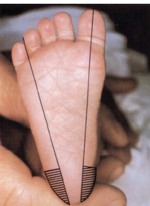
- Select a puncture site for your child.
- Choose the side surface of the heel, free of scars, cuts, bruises or rashes.
- Shaded/line-filled areas are the safe areas to do a heel puncture.

- Prepare to collect the blood sample.
- Find a comfortable seating position with your child and arrange the content of the kit in front of you.
- Warm your child’s entire foot to help increase blood flow. You can wrap the foot with a warm, moist towel at a temperature no higher than 42°C for 2-3 minutes.
- Wash your hands thoroughly with warm water and soap for at least 20 seconds.
- Clean the selected puncture site with warm soapy water. Wash with a gentle circular motion for at least 20 seconds. Rinse and dry completely.
- Cleanse the selected site with alcohol swab. Allow the skin to air dry.

- Perform the heel prick.
- Twist and pull the protective cap away from the lancet. Carefully set the cap down.
- Hold the lancet between the fingers of one hand, and use your other hand to hold your child’s foot securely. Pull skin tight at puncture site.
- Press button on the lancet with forefinger to make the puncture. Set the lancet aside to mail back to VEC later.
- Wipe off the first drop of blood with a sterile gauze.
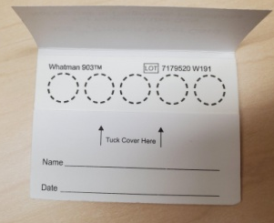
- Collect the sample on the 903 protein saver card.
- Allow a second large blood drop to form. It may help to gently massage the surrounding area of the heel to stimulate blood flow.
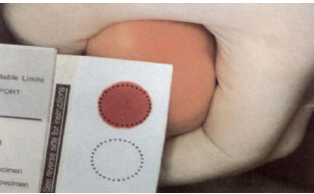
- Gently touch the large blood drop to the center of the 1st circle on the card and, in one step, allow a sufficient quantity of blood to soak through and COMPLETELY fill the circle and soak through the back (do not let the heel touch the card!).
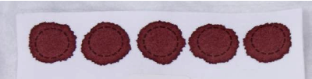
- Move the heel to the next circle and repeat the previous step. Continue to fill all 5 circles (or as many as you can). Remember that 3 completely filled circles are better than 5 incomplete circles. If blood stops flowing before 3 circles are filled, you can use the second lancet to prick a different area of the heel.
  - Multiple small drops of blood can be dropped onto the same circle, but don’t overlay them.
  - Avoid excessive “milking” or squeezing the area around the puncture site.
  - Avoid touching or smearing spots.
4. When completed, place a sterile gauze against the heel until the bleeding stops.
5. Put the used lancets into the labelled coin envelope.

E. Dry the sample.
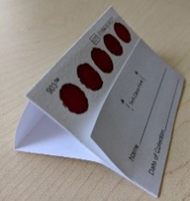
- Let the card dry for at least 3 hours: using the cover flap of the protein saver card, prop the blood spots up and lay the card face up on a clean surface, and avoid touching it or knocking it over.
- Dry the card away from direct heat and sunlight. Do not refrigerate.
- Once the card is dried, fold the paper flap on the card to cover the spots. Ensure the date and time of collection is written on the highlighted label on the card.

F. Pack the sample for mailing.
- Put the dried card into the coin envelope labelled “DBS Card.”
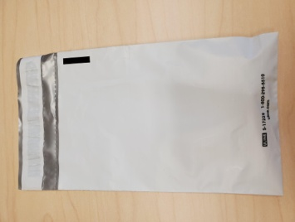
- Place this coin envelope in the clear resealable bag provided (keep the absorbent packet and the humidity indicator card inside the bag).
- Squeeze as much air out as possible, then seal the bag.
- Put the clear resealable bag and the other coin envelope with used lancets in the plastic return envelope, and mail it back to the VEC. You do not have to pay postage.
PLEASE MAIL THE PACKAGE WITHIN 24 HOURS AFTER SAMPLE COLLECTION. THANK YOU!

EXAMPLES OF INVALID BLOOD SPOTS

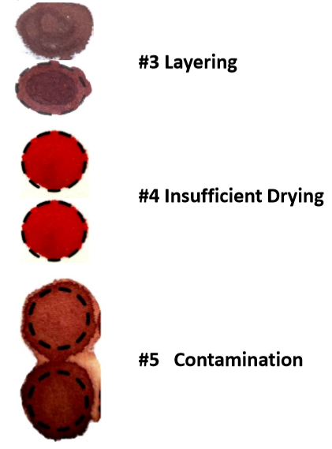
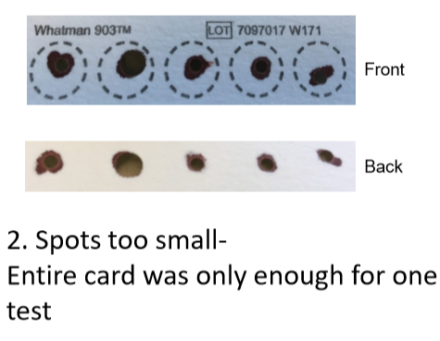
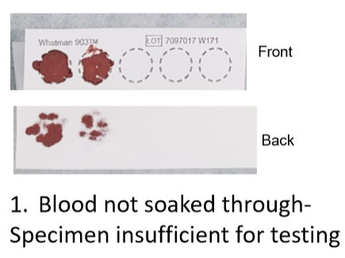
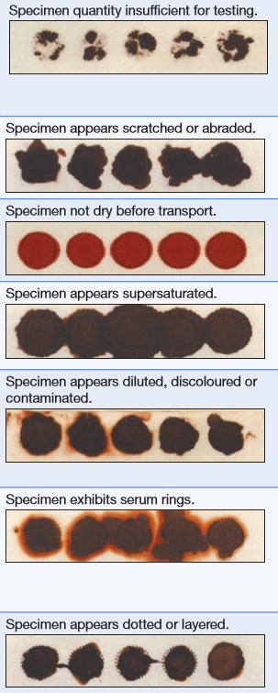
Overlaying
Neonatal Guideline: Newborn Metabolic Screening. 2018. Perinatal Services BC

PLEASE REFER TO NEXT PAGE FOR EXAMPLES OF ACCEPTABLE BLOOD SPOTS
Collection of Dried Blood Spots (Experienced Users Protocol). 2019. National HIV & Retrovirology Laboratories. Public Health Agency of Canada.
EXAMPLES OF ACCEPTABLE BLOOD SPOTS

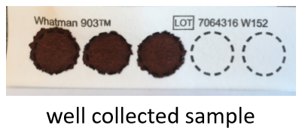
Collection of Dried Blood Spots (Experienced Users Protocol). 2019. National HIV & Retrovirology Laboratories. Public Health Agency of Canada.

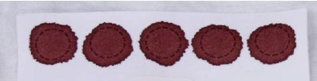

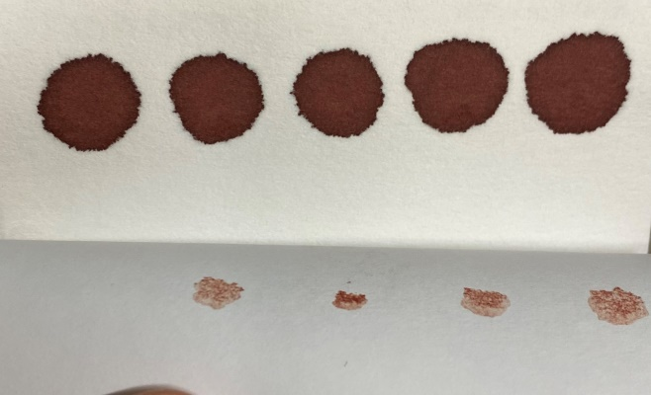
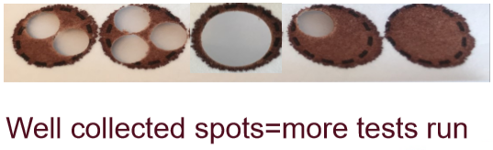
Front of Card
Back of Card
Module 14: EQA Blood Collection and Handling – Dried Blood Spot (DBS). 2005. World Health Organization
Collection of Dried Blood Spots (Experienced Users Protocol). 2019. National HIV & Retrovirology Laboratories. Public Health Agency of Canada.

